Voltage source theorem

Laboratory 6 of Electrotechnics and Electrical Machines

The picture from the Falstad platform:

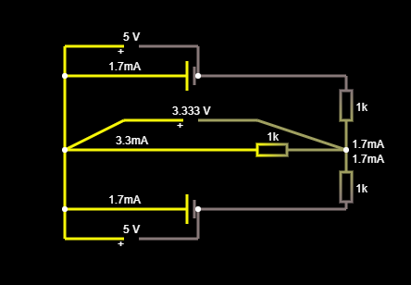

Cables

Voltmeter

Resistors of 1000 Ω

Generators

Wires that indicate I = 1.667 A

Branch AB

IAB= I1+I2 = 1.667 + 1.667 = 3.334mA; UAB = IAB x RAB = 3.333 x 10^3 x 10^(-3) = 3.333 V; 1.7 mA in the circuit is an approximation of the current of 1.667 mA; RAB is given by the only 1000 Ω resistor in branch AB; I4, I5 = IAB/2 = 1.667 = 1.7 mA (Whatever current enters branch AB, just as much must also exit. This fact is demonstrated by the Falstad schematic)